**A Report of In-Plant Training**

**at**

**YBI FOUNDATION**

**Submitted by**

**POLAKA BALA CHAITHANYA REDDY**

*in partial fulfillment for the award of the degree*

*of*

**BACHELOR OF TECHNOLOGY**

*in*

**COMPUTER SCIENCE ENGINEERING**



**SRI VENKATESHWARA COLLEGE OF ENGINEERING AND TECHNOLOGY(AUTONOMOUS)**

**JAWAHARLAL NEHRU TECHNOLOGY UNIVERSITY,ANANTAPUR**

**JULY,AUGUST-2022**

i

**CERTIFICATE**

**Certified that this Report of In-Plant Training at**

**“……….YBI FOUNDATION……………..”**

**Being submitted herewith to the**

**SRI VENKATESHWARA COLLEGE OF ENGINEERING AND TECHNOLOGY(AUTONOMOUS)**

**is the bonafide work of**

**“…………..POLAKA BALA CHAITHANYA REDDY.…………”**

**who carried out the project work under our guidance and supervision.**

|  |  |  |
| --- | --- | --- |
| **<< Name>>**  **Guide** | **<< Name>>**  **Head of the Department** | **<< Name>>**  **Principal** |

**NAME OF YOUR DEPARTMENT**

**SRI VENKATESHWARA COLLEGE OF ENGINEERING AND TECHNOLOGY(AUTONOMOUS)**

**JAWAHARLAL NEHRU TECHNOLOGY UNIVERSITY,ANANTAPUR**

ii

**ACKNOWLEDGEMENT**

I would like to express my special thanks of gratitude to my In-Plant Training guide << Name of guide>>, Head of the Department <<Name of HOD>> as well as our principal << Name of guide>> who gave me the golden opportunity to do this wonderful in-Plant Training at << YBI FOUNDATION >>, which provided me an opportunity explore the new horizons.

I sincerely express my gratitude towards the << YBI FOUNDATION>> for providing this opportunity.

Secondly I would also like to thank my parents and friends who helped me a lot in finalizing this report within the limited time frame.

|  |  |
| --- | --- |
| Date : | << POLAKA BALA CHAITHANYA REDDY >> |
| Place :Chithoor | << 20781A05B6 >> |
|  | << 3RD B-TECH>> |

iii

**TABLE OF CONTENTS**

|  |  |  |
| --- | --- | --- |
|  | **TITLE** | **Page No.** |
|  | Cover Page | i |
|  | Certificate | ii |
|  | Acknowledgement | iii |
|  | Table of Content | iv |
|  | List of Tables | vi |
|  | List of Figures | vii |
|  | List of symbols and abbreviations | viii |
| **1.0** | **INTRODUCTION** | **1** |
|  | 1.1 Sub section | 1 |
|  | 1.2 Sub section | 1 |
| **2.0** | **COMPANY PROFILE** | **2** |
|  | 2.1 Sub section | 2 |
|  | 2.2 Sub section | 2 |
| **3.0** | **DEPARTMENT PROFILE** | **3** |
|  | 3.1 Sub section | 3 |
|  | 3.2 Sub section | 3 |
| **4.0** | **PROJECT WORK** | **4** |
|  | 4.1 Sub section | 4 |
|  | 4.2 Sub section | 4 |
| **5.0** | **CASE STUDY** | **5** |
|  | 5.1 Sub section | 5 |
|  | 5.2 Sub section | 5 |
| **6.0** | **CONCLUSION** | **6** |
|  | **REFERENCES** | **7** |

v

**LIST OF TABLES**

|  |  |  |
| --- | --- | --- |
| **Table No.** | **Title** | **Page No.** |
| Table 1.1 | Name of the table | 1 |
| Table 2.1 | Name of the table | 2 |
| Table 3.1 | Name of the table | 3 |

vi

**LIST OF FIGURES**

|  |  |  |
| --- | --- | --- |
| **Figure No.** | **Title** | **Page No**. |
| Figure 1.1 | Name of the figure | 1 |
| Figure 1.1 | Name of the figure | 2 |
| Figure 1.1 | Name of the figure | 3 |

vii

**LIST OF SYMBOLS AND ABBREVIATIONS**

|  |  |
| --- | --- |
| **Symbol** | **Explanation** |
| $ | Dollar |
|  |  |

viii

1. **INTRODUCTION**

The purpose of this section is to provide brief background information and introduction of the work carried out during the In-plant training . It should not exceed two pages (2) but should be a minimum of 300 words and should comprise the following topics:

1. Company information : Brief information about the company where you completed your training
2. Training Objective: Description of the student’s internship objective and work accomplishments
3. Student’s Work Assignment: A general, non-technical presentation of the student’s function within the company and his work assignments
4. **COMPANY PROFILE**

A brief and clear presentation of the type of business of the company and the functions of the department(s) in which the internship was carried out.

Following points can be added

* History and present situation of company
* Companies products, services and processes
* Companies customer base and market conditions
* Its various departments or divisions



Figure 2.1 : Title of the image

1. **DEPARTMENT PROFILE**

In this section you can write detailed information about department / division / service section where you were working during the internship

Table 3.1 : Title of the table

|  |  |  |
| --- | --- | --- |
| **Heading** | **Heading** | **Heading** |
| Data | Data | Data |
| Data | Data | Data |

Figure 3.1 : Title of the image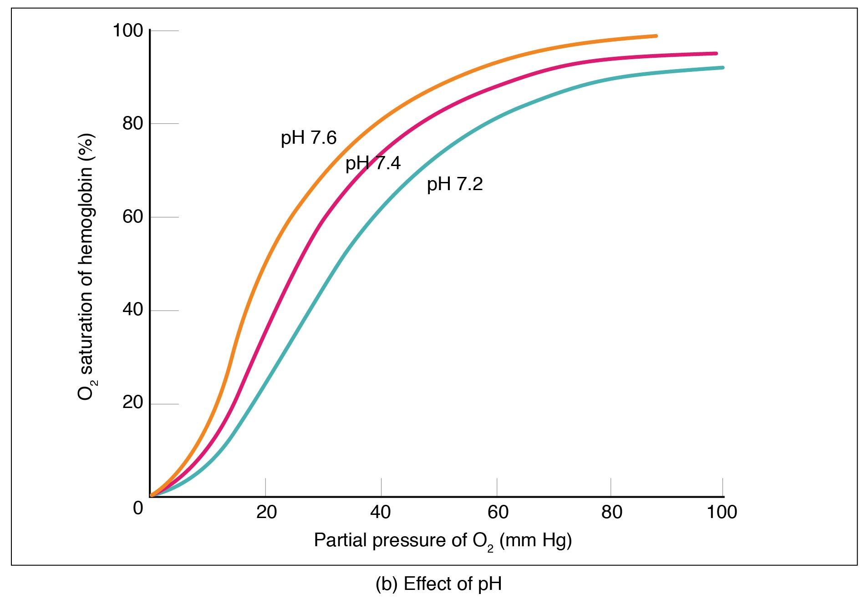

1. **PROJECT WORK**

This is a core section of your report. Describe the work that you have accomplished during this internship, the techniques that have learned, the skills which has acquired, the contributions made, the responsibilities that you have assumed, the equipment you have used, the safety procedures he has followed and all other pertinent information.

It contains all the crucial technical details including illustrations, equations, programs, software versions, graphs, tables, charts, diagrams, etc. These should be clearly numbered and/or titled for easy reference. Units, scales, labeling of the axes must be provided for easy understanding. The technical part may be presented in the form of chapters, sections or any other arrangement suitable to the nature of the technical report.

1. **CASE STUDY**

In this section you can describe any case studies that you have performed during the internship.

Following points can be considered for writing case study

* What is the problem? (Problem statement)
* Objective of case study
* Data collection
* Analysis of problem
* Solution provided
* Implementation of solution
* Results

1. **CONCLUSION**

The conclusion and recommendations part summarizes the whole report by highlighting all the chapters and their significance and the importance of the project and the achievements.

**REFERENCES**

1. Shin, K.G. and Mckay, N.D. (1984) ‘Open Loop Minimum Time Control of Mechanical Manipulations and its Applications’, Proc.Amer.Contr.Conf., San Diego, CA, pp. 1231-1236.